**W8 mini assignment**

**Student ID: 490111165 Student Name: Jialu He**

Task 1

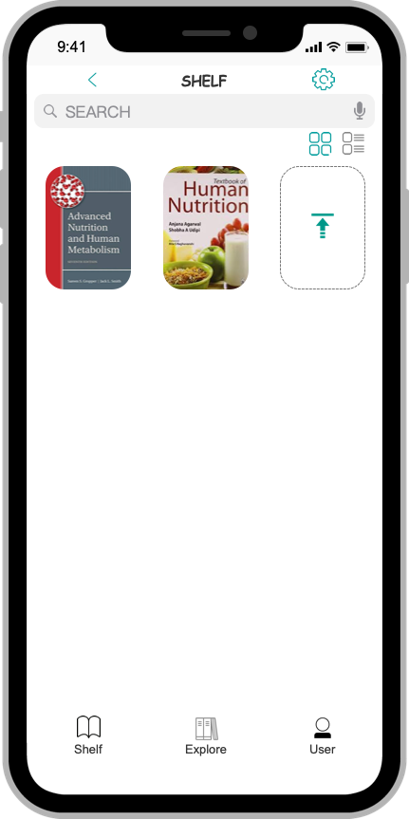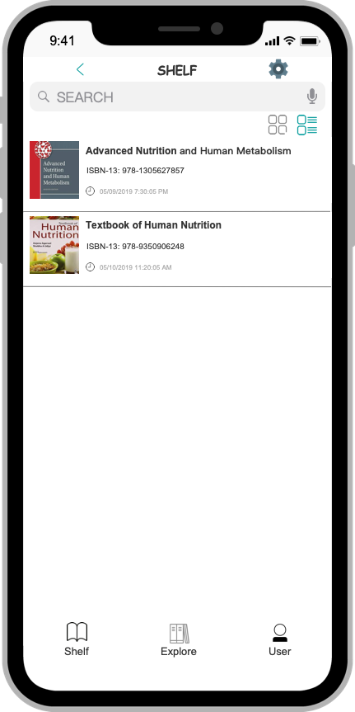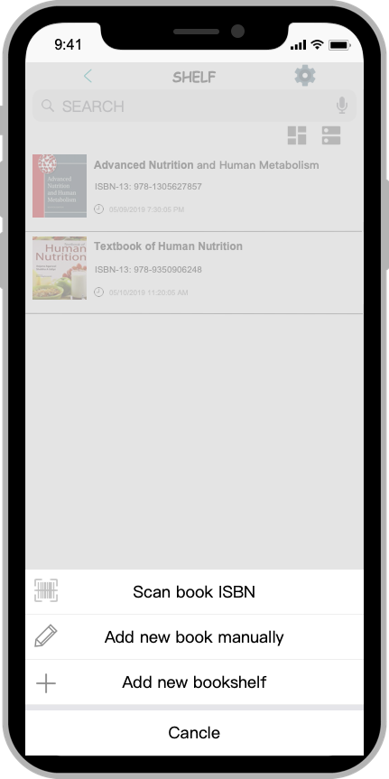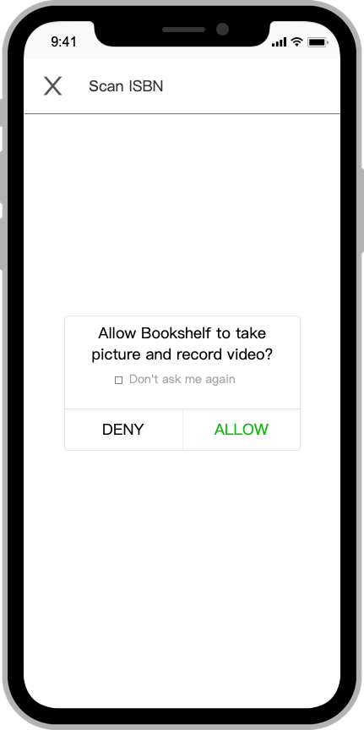

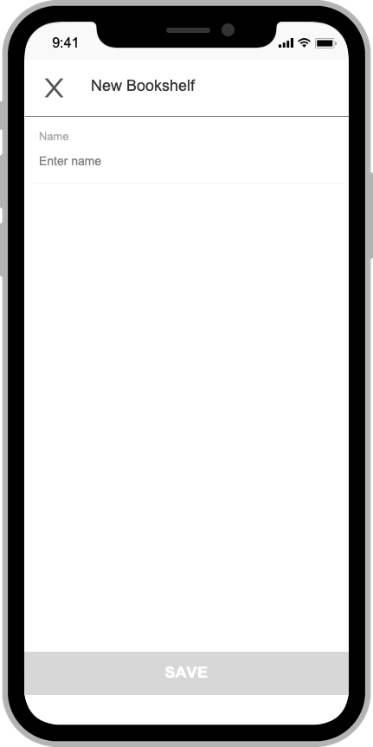

Task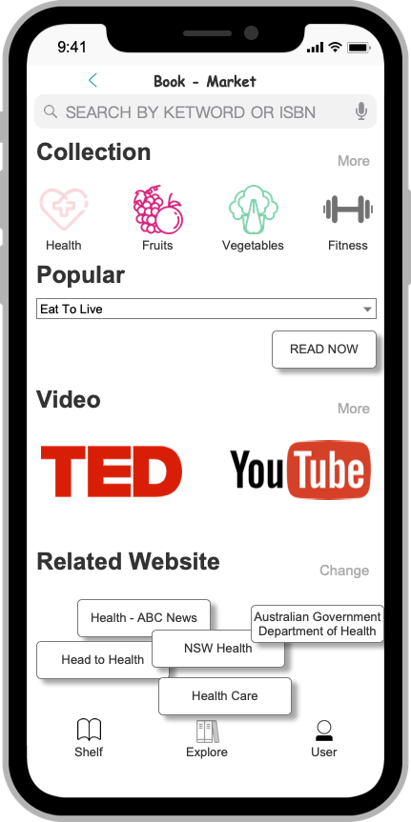 2

**Abstract Task 1: Deep learning**

1. If you want to learn more information on TED video, show me what you will do.
2. If you want to learn more knowledge on some related website, such as NSW Health, show me what you will do.
3. If you want to look some popular book, which is named “Eat to Live”, show me what you will do.

**Abstract Task 2: Gain more resource**

1. If you find an interesting book but you only know the ISBN number, show me what you will do to find this book.
2. If you want to arrange your bookshelf space and add a new bookshelf, which is named “2019S2”, show me what you will do.
3. If you find a useful book and you want to add some basic information about this book in the bookshelf, show me what you will do.

**Abstract Task 3: Re-arrange your bookshelf**

1. If you want to see when you read this book last time from bookshelf, show me what you will do.
2. If you only want to see the picture of the book, show me what you will do.